St Mirren Youth Football Club have a fine reputation for encouraging sportsmanship and fair play. We would like this to continue and good behaviour to apply to players, officials, and spectators. Accordingly, all parents, carers and supporters are expected to agree to the following: -
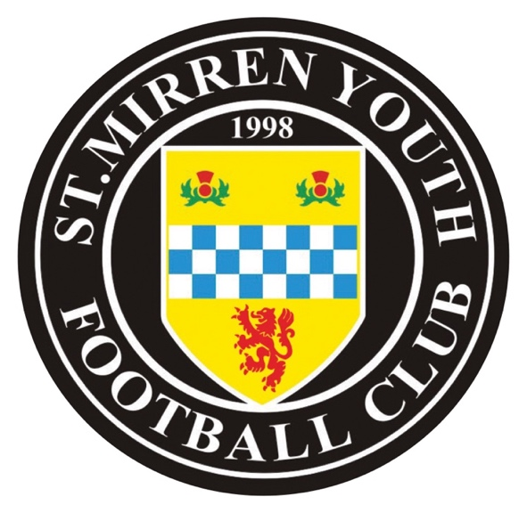
Act in a dignified manner and with the highest level of integrity and ensure that the reputation of the club remains high.

Remember that the players are playing for their own enjoyment and not for the ambitions or egos of parents. Parents should foster enthusiastic participation through team managers, coaches, and assistants.

Encourage the team and players development through self-improvement and fair play. Respect the facilities and pitch equipment at both home and away grounds.

Refrain from using or encouraging the use of comments that can in any way be regarded as racist, sexist or any other form of discrimination.

Remember that the team managers/coach’s decision is final. Emphasise respect for coaches and their assistants by not publicly questioning their decision making.

Acknowledge the value and importance of managers/coaches as they have given freely of their time to provide sporting opportunities for your child.

Coaches will have a competent level of expertise in Football Coaching and the Principles of Play. Coaches will have taken part in the SFAs Coach Education Programme from Level 1 onwards, including Basic First Aid through to professionally recognised SFA Licence and Diploma holders.

Refrain from coaching, criticising, or instructing the players on game day as this is the sole responsibility of the manager, coach, and assistants.

Please do not verbally abuse, humiliate, or intimidate players, managers, coaches, referees, other match officials or spectators. Do not use or encourage the use of bad language, foul play, or cheating.

Please do not enter the field of play before, during or after the match, or make derogatory comments to the players or manager, coaches, officials or other parents or spectators at any time.

Parents, carers & supporters are expected to allow the coaches to coach as One Voice from the sidelines. The only voice they should take instruction from are the coaches – do not interfere!

Let them Play! – Parents should let the Players play - it’s their game, not yours!
Applaud good play by both sides – children learn best by example. If games must be postponed or cancelled for whatever reason - remember that this is out of consideration for your child’s safety.

Parents, carers & supporters with any issues or concerns should arrange to speak to coaches or officials after Club activities, coaching sessions, games and/or matches and certainly away from the field of play.

Parents, carers & supporters should be aware that failure to accept or abide by this charter could result in being asked not to attend matches and could ultimately affect your young footballer’s participation in coaching sessions and team selection.
* * * * *
Coaches select players and ‘coach’ the team - not parents, carers & supporters and not players.

We look forward to your support!

Together we can assist individuals to develop their skills and abilities and reach their full potential in a competitive but friendly and pleasant atmosphere in a controlled environment.

Remember:

• Encourage your child to learn the rules and play within them.

• Discourage unfair play and arguing with officials.

• Help your child to recognise good performance, not just results.

• Never force your child to take part in sport.

• Set a good example by recognising fair play and applauding good performances of all.

• Never punish or belittle a child for losing or making mistakes.

• Publicly accept officials' judgements.

• Support your child's involvement and help them to enjoy their sport.

• Always use correct and proper language.

• Encourage and guide performers to accept responsibility for their own performance and behaviour.

Frank Sweeney, Club Secretary

